Chapter 7, Solution 67.

If v(0) = 5 V, find v_{o}(t) for t > 0 in the op amp circuit in Fig. 7.132.
Let R = 10 kΩ and C = 1 μF.

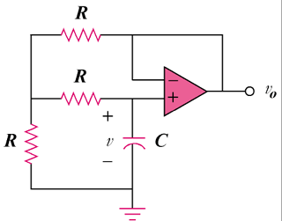

Figure 7.132
For Prob. 7.67.

Solution

The op amp is a voltage follower so that as shown below.

R

R

v₁

C

+

v_{o}

+

R

v_{o}

v_{o}

At node 1,

At the noninverting terminal,
,

5e^{–100t/3}u(t) V

